Bad Temperature Indicators

Introduction

This article is about bad temperature indicators that do not work well. The circuits shown in this article are not completely wrong because the electronic components would not burn when power is applied. However, the circuit does not work well enough to be considered correct.

In each of the circuits shown, you see ten thermistors connected to the LED (Light Emitting Diode), 1 k𝛺 resistor and a 9 V battery. All components shown in the circuit are connected in series.

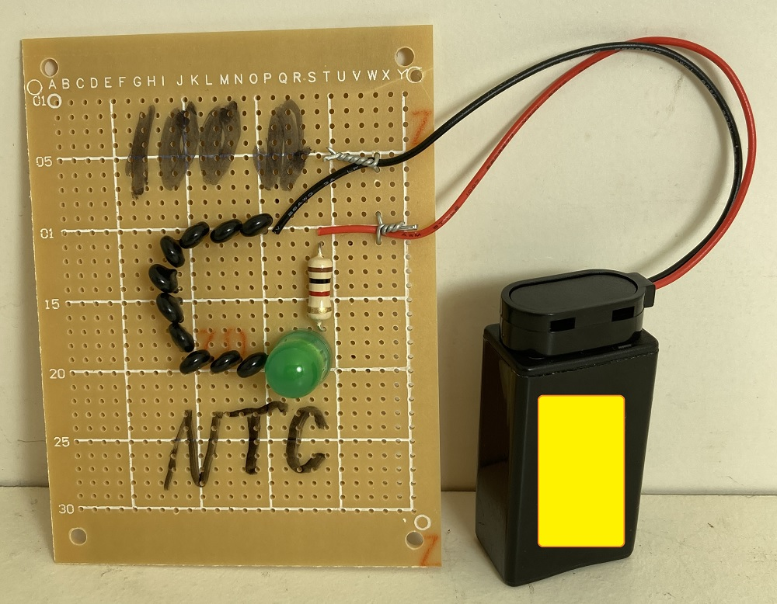 | 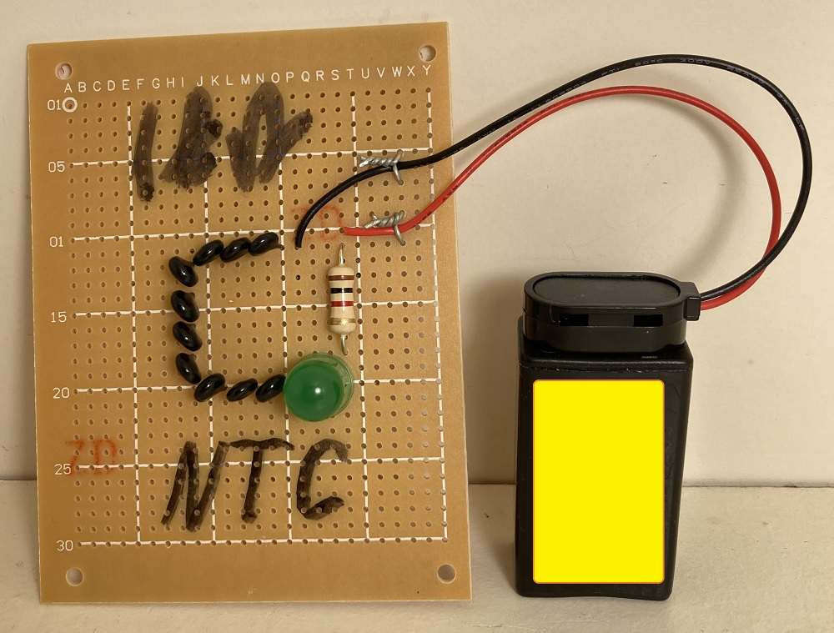
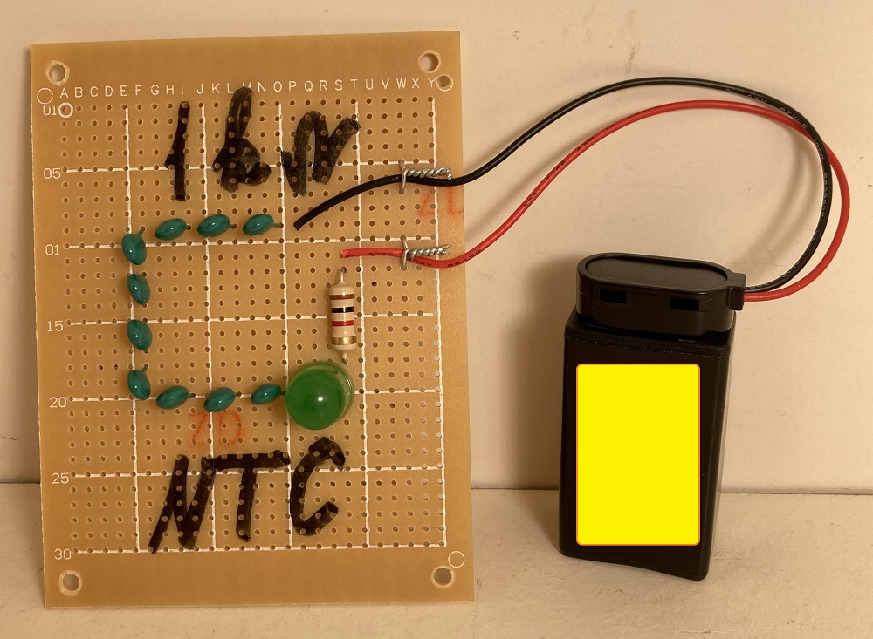 | 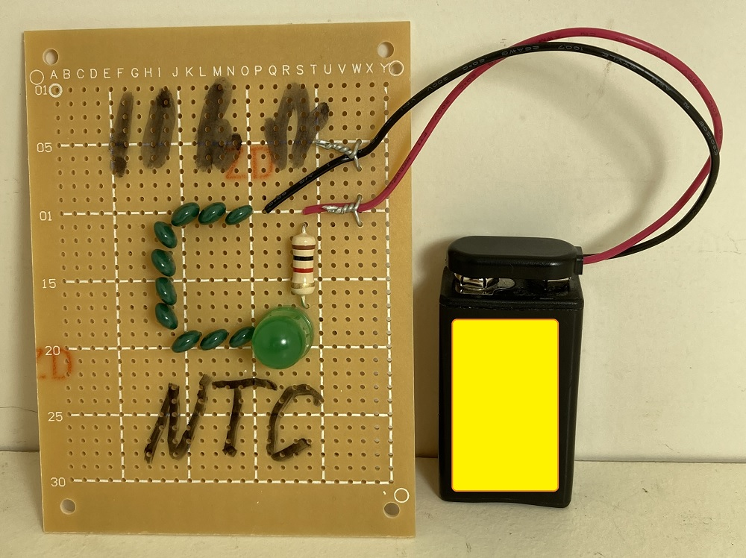
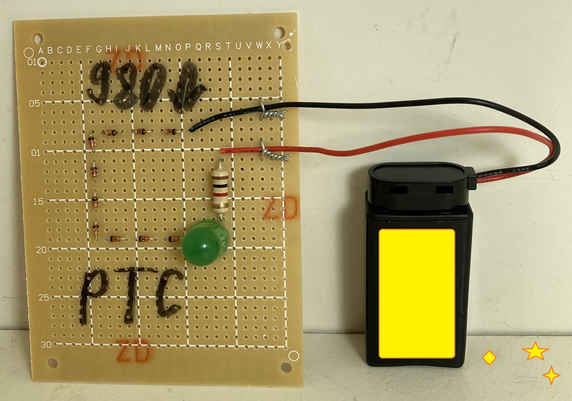
Figure 1: Thermistor Circuits.

Thermistors change their resistance value with the temperature of the environment in which the thermistor is placed. This temperature change will cause a change in LED light intensity due to a change in the series electrical current. There are two types of thermistors. Negative Temperature Coefficient (NTC) and Positive Temperature Coefficient (PTC) thermistors. Negative Temperature Coefficient thermistors decrease in resistance when the thermistor case temperature increases. This will increase the LED light brightness. Positive Temperature Coefficient thermistors increase in resistance when the thermistor case temperature increases. This will decrease the LED light brightness.

Step 1: Design the Circuit

The design of the five circuits is similar. The only difference is the resistance values of the thermistors and the thermistor types.

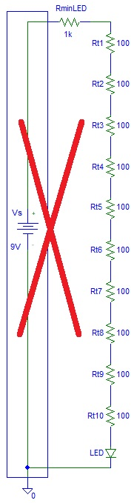 | 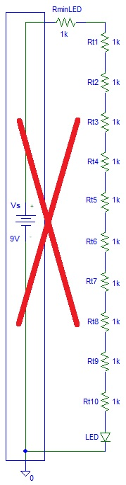 | 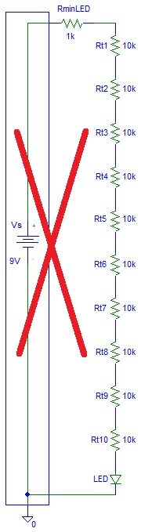
Figure 2: Circuit Design.

I put a cross in all three circuits because testing will show that the circuits do not work.

The LED current will be equal to:

$I_{LED}=\frac{V_{s}-V_{LED}}{R_{minLED}+R_{t1}+R_{t2}+R_{t3}+R_{t4}+R_{t5}+R_{t6}+R_{t7}+R_{t8}+R_{t9}+R_{t10}}$

Where: $V_{s}=$ Power Supply Voltage (V, volts)
$V_{LED}=$ LED Voltage (V, volts)
$R_{minLED}=$ Minimum Resistance (𝛺, ohms)
$R_{t1}+R_{t2}+R_{t3}+R_{t4}+R_{t5}+R_{t6}+R_{t7}+R_{t8}+R_{t9}+R_{t10}=$ Total Thermistor Resistance (𝛺, ohms)

You can see from the formula above how thermistor resistance changes the value of LED current. You can also see why I included the $R_{minLED}$ component to prevent failure of the LED when the thermistor resistance is near zero.

Since: $V_{s}=$ 9 V, $V_{LED}=$ 2 V, and $R_{minLED}=$ 1000 𝛺 then:

$I_{LED}=\frac{7}{1000+R_{t1}+R_{t2}+R_{t3}+R_{t4}+R_{t5}+R_{t6}+R_{t7}+R_{t8}+R_{t9}+R_{t10}}$

Step 2: Make the Circuit

You have already seen the photos of the circuit. I made five circuits without a soldering iron. I twisted the wires with pliers. At times, not using the soldering iron is not a good idea because over the years, connections between components will become worse due to rust.

Step 3: Testing

Testing showed that the most reasonable circuit is the one with 10 k𝛺 thermistors. If you look carefully, you can see an increase in LED light intensity in that circuit (10 k𝛺) when heat from a hair dryer is applied.

You can see the circuit testing videos by clicking on the following YouTube links:

100 𝛺 NTC Themistors:
https://www.youtube.com/shorts/dHIprieTJU8

1 k𝛺 NTC Thermistors: https://www.youtube.com/shorts/ZYLyPtKHWng

10 k𝛺 NTC Themistors: https://www.youtube.com/shorts/d_B_kax8Y68

930 𝛺 PTC Themistors:
https://www.youtube.com/shorts/AqAq51TxQ9A

Discussion

Because the 10 kohm thermistors circuit worked reasonably well, a good solution to the problem is increasing the power supply voltage and increasing the thermistor resistance values. Thermistors that have high resistance values have a higher change in resistance value with temperature, thus a higher change in LED light intensity.

Conclusion

Sometimes electronics design is about trial and error. In this case, results have shown that a change in temperature causes little or unnoticeable change in LED light intensity. This is why all five circuits are bad.

